Appendix 'A'

Lancashire as part of an Interconnected and Productive Northern Powerhouse

The Lancashire Strategic Transport Prospectus

Foreword
Lancashire’s economic strengths, and more importantly its economic potential over the next two decades, is arguably one of the least understood dimensions of the emerging Northern Powerhouse vision.

With an economy of over £25 billion, Lancashire is home to over 40,000 businesses. We are the UK’s leading region for aerospace manufacture, and related industries, and have rapidly growing clusters across energy, advanced manufacturing, chemicals and automotive sectors.

We also have a strong visitor economy, boast three world- class universities, and are surrounded by some of the country’s most outstanding rural and coastal beauty.

But Lancashire also faces a huge challenge – how do we not only maintain the considerable competitive advantages and unique assets we already have but, in addition, how do we grasp the opportunity offered by initiatives like the Northern Powerhouse?

The answer from my point of view is simple – the integration of key strategic investments, clearly aligned to complementary economic strategies, and the robust physical connectivity to join all of these together in order that our residents and businesses, and those we need to attract in order to grow, can take full advantage of all we have to offer.

Further, this connectivity needs to reach beyond the borders of Lancashire itself - improving local transport networks is a key priority of the Lancashire Enterprise Partnership and partners – but it is our connection with the rest of the North, the rest of the United Kingdom, and the rest of the world which will largely determine the pace and level of our success going forward.

In Northern Powerhouse terms this means capitalising on Lancashire’s strategic importance geographically. We are the only area which borders two of the biggest city-regions Manchester and Liverpool, which will drive much of the North’s economic renaissance, and we also count North and West Yorkshire, and Cumbria, as our immediate neighbours.

Therefore to maximise our role at the heart of what we call ‘Northern Powerhouse West’, we must work with partners to deliver the rail, road and other transport infrastructure needed to ensure that people, goods and services get where they need to be to stimulate growth and prosperity for all. With this in mind I am looking forward to providing political representation for Lancashire and Cumbria on Transport for the North’s new Partnership Board.

Many of Lancashire’s requirements and aspirations in this regard are already being assessed, planned and costed, and you will find details of a wide range of transport and infrastructure projects already underway or anticipated in this Prospectus.

Building on our Strategic Economic Plan, which aims to create an additional 50,000 jobs over the next ten years, this prospectus reflects the importance of the county’s nationally recognised City Deal and conveys the ambitious Growth Plan we have in place and the potential offered by our Enterprise Zones.

The Lancashire Enterprise Partnership has made strong progress in recent years and established a growth programme of national significance. However, given our underlying performance of recent decades we cannot afford to be complacent. Our Prospectus, and the delivery of its key priorities, is central to our purpose of re-establishing Lancashire as a national economic driver. The analysis set out in our Prospectus demonstrates that our programme will deliver 15,000 net new jobs, increase productivity by £185M per annum and contribute an additional £685M GVA a year to the Northern Powerhouse economy.

The prospectus identifies our long-term strategic transport requirements, the opportunities and constraints on growth over the next twenty years, and also the more immediate interventions needed to stimulate Lancashire’s latent potential.

So even though this Prosepectus is fundamentally about Lancashire’s evidenced case-making to support more and better physical connectivity, both across the county itself and further afield to improve our access and economic influence over the Northern Powerhouse as a whole, it is also about the importance of the developing connectivity solutions which generate maximum benefit for our local communities and economies

These interlinked factors are also at the heart of the government’s vision for a more connected and more productive North, and it is one which Lancashire wholeheartedly embraces.
Jennifer Mein Chair of Transport for Lancashire
Lancashire Enterprise Partnership

- Introduction
Lancashire is a dynamic economic region within the North West and the wider North of England. It has a unique offer to make and role to play in the Northern Powerhouse.
Lancashire's leading international and national position in relation to aerospace, advanced engineering and manufacturing, energy, higher education institution excellence and visitor economy make it a pivotal part of the long term economic growth of the North.
Lancashire has close links to both the Manchester and Liverpool city regions. In both cases it provides many high skilled workers in key growth sectors, and this has increased as transport improvements have enabled many people to live in the most attractive parts of Lancashire and commute to work. As important, many growth sectors are linked to supply chain and business networks which extend across LEP boundaries to larger functional economic geographies. Strengthening these business inter-actions and accelerating agglomeration benefits is an economic imperative for Lancashire and the Northern Powerhouse.
As elsewhere within the Northern Powerhouse, connectivity is fundamental to maximising growth potential. Those transformational and supporting transport interventions that underpin strategic economic growth in Lancashire and the wider North need to be prioritised and delivered as part of an integrated approach.
The purpose of this strategic transport prospectus is to:
- Set out the importance of the Northern Powerhouse to the competiveness of UK, and the role and contribution of the Lancashire economy;
- Articulate Lancashire's economic growth priorities with a focus on those that play a critical role within the Northern Powerhouse;
- Demonstrate the rationale for developing a multi-modal transport network to support Lancashire's economic growth and that of the Northern Powerhouse;
- Confirm Lancashire's track record and ability to deliver;
- Present the national and local strategic transport priorities for Lancashire and their economic benefits to the Northern Powerhouse; and
- To set out the timescales for delivery.
This Prospectus also seeks to identity the economic impact of transport investments, including employment growth from new employment land. In addition, consideration is given to the housing impact resulting from residential land, in line with the Chancellor's recent statement on the contribution of housing to productivity and economic growth.

- Lancashire’s Unique Place in the Northern Powerhouse Jigsaw

Valued at over £25 billion, Lancashire has one of the largest economies in the North of England and is home to over 40,000 businesses employing in excess of 670,000 people, and has a population of 1.4 million.
Rebalancing the economy by transforming growth across the North of England and establishing a Northern Powerhouse is a core part of the Government's economic strategy. In June 2014, the Chancellor of the Exchequer set out his vision for a 'Northern Powerhouse', a collection of northern cities sufficiently close to each other that, when combined economically would be able to challenge the world and in so doing, contribute to rebalancing the UK's economy The Northern Powerhouse is a £315bn economy (2013) with two economic centres of gravity: Manchester, leading a powerful economy which makes up Northern Powerhouse West, and Leeds, dominating an extended geography covering Northern Powerhouse East. A major objective of the Northern Powerhouse is to strengthen east west linkages through improved transport connectivity, including rail and road improvements, helping to integrate two powerful super regions into a single functional economy, creating new levels of agglomeration benefits.
Northern Powerhouse
West | GVA (£bn) | East | GVA (£bn)
Cumbria | 9.7 | North East | 33.9
Lancashire | 25.5 | Tees Valley | 11.4
Greater Manchester | 56.3 | Leeds City Region | 60.2
Cheshire and Warrington | 23.2 | York/N York/E Riding | 21.6
Liverpool City Region | 27.0 | Sheffield City Region | 30.6
 |  | Humber | 16.3
Northern Powerhouse | West £141.7 |  | East £174.0
Source: Regional Accounts

Independent economic analysis has highlighted the presence of business and industrial clusters in growth sectors across and within key locations in Lancashire. These sectors have the potential to deliver a scale of growth that will have a transformative impact on the local economy and contribute significantly to the northern and national economy.
- Advanced Manufacturing: Aerospace and Automotive;
- Energy;
- Higher Education;
- The Visitor Economy;
- Professional and Business Services; and
- Logistics.
In each of these areas Lancashire has key physical, locational and research assets; business strengths with world class companies and development plans to increase innovation, quality, productivity and growth.

It is fundamental to the Northern Powerhouse that key growth sectors reach their full potential. This means targeting innovation, skills and supply chain solutions to maintain and grow investment. It means matching skills to the business growth areas of the future, providing new models of business support and economic regeneration and better connecting people to jobs, education and training and to other opportunities.

Growth Sectors identified in Strategic Economic Plans
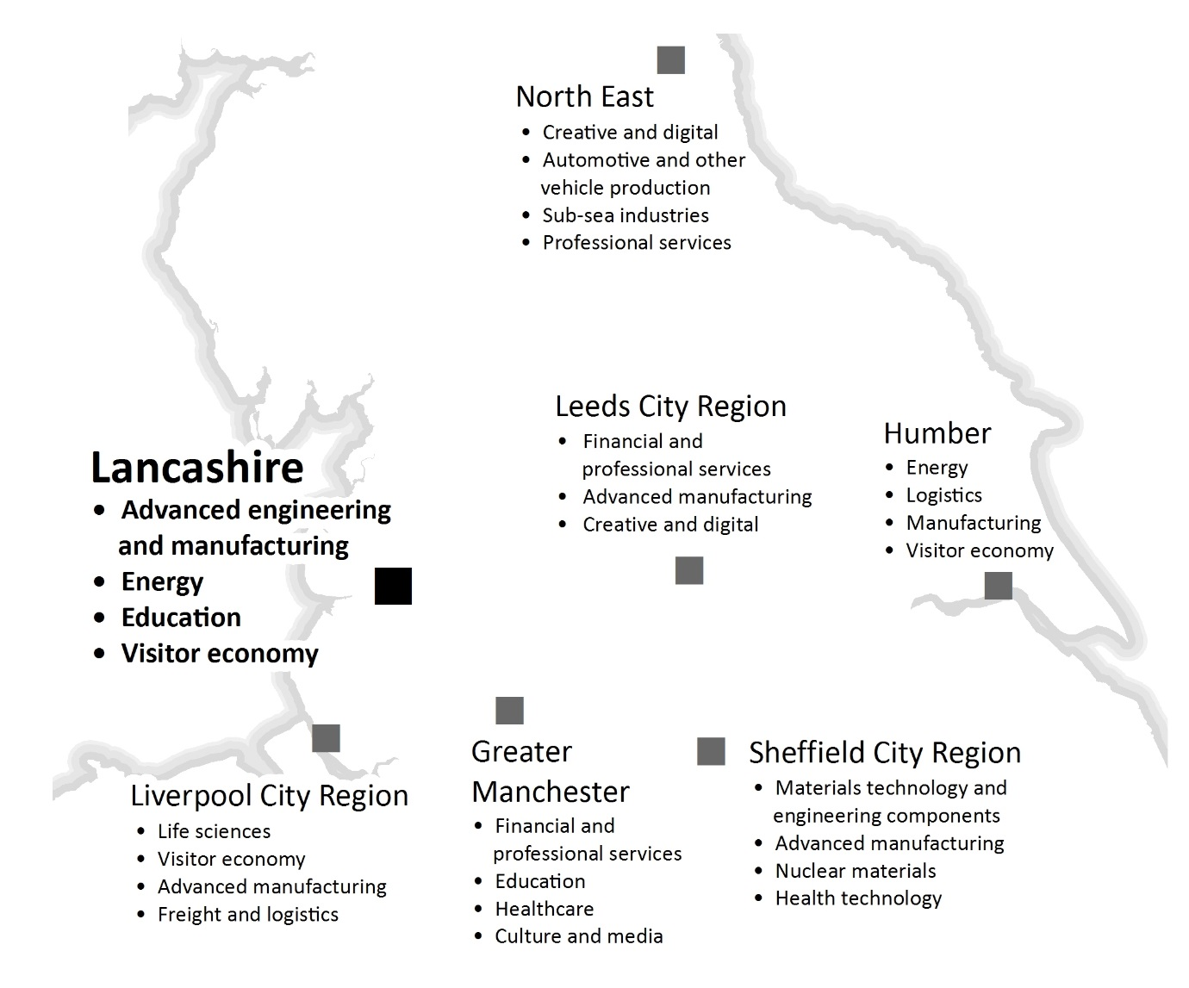 Source: Transport for the North (modified)

Advanced Engineering and Manufacturing: Aerospace and Automotive
Lancashire is central to a regional cluster of aerospace capability recognised as the fourth largest in the world. One of three key clusters of aerospace capability in the UK, it is the only one in the North of England, contributing £850m to the national economy. As a result, Lancashire is a powerful force in the whole supply chain of this industry. The county hosts the single largest concentration of aerospace production in the UK, employing over 20,000 people. Major employers include BAE Systems, Rolls Royce and Safran-Aircelle. These internationally renowned companies have attracted, and support, strong supply chains in design, testing, manufacturing and repair and maintenance. Lancashire's Enterprise Zone focuses on these sector strengths to provide world-class development opportunities. BAE Systems' Lancashire sites are contributing in the region of £6 billion in value to the F35 programme, which is the UK's single largest trade contract.
The automotive sector has an important base in Lancashire, with a workforce of over 3,500. Key companies include PACCAR (Leyland Trucks), Piolax, Sanko-Gosei, Erlson, Futaba-Tenneco and TRW Automotive. The supply chain is significant, with the majority of business activity focussed on the supply of high value parts to the UK and European Original Equipment Manufacturers (OEMs), a key Lancashire capability that the UK as a whole is seeking to grow. Exploiting a legacy of testing facilities, Lancashire hosts a significant cluster of innovative design and development companies, including Torotrak, Clean Air Power and Scorpion Automotive.
Energy
Over 37,000 people in Lancashire work in the power generation sector. The sector enjoys strong support from Lancaster University and the University of Central Lancashire, both of whom are internationally recognised centres of excellence in energy and environmental studies. National companies operating in the sector include Springfield Fuels, EDF, AMECPLC, SITA, Assystem and Westinghouse-Toshiba. Westinghouse facilities in Lancashire have nuclear reactor and fuel processing contracted programmes valued in the hundreds of millions of pounds.
The two nuclear power stations at Heysham represent one of the largest concentrations of power generation in the UK. Decommissioning is anticipated to commence at Heysham 1 in 2019, with Heysham 2 following soon after. The close proximity of Lancashire to a number of Nuclear Decommissioning Authority sites makes it an ideal central location from which to serve the industry. Also, the Springfields Fuels site has the capability and capacity to manufacture fuel for all designs of worldwide nuclear reactors.
The specific strengths of Lancashire's nuclear sector, if appropriately combined with key assets and opportunities in Cumbria, Manchester, Cheshire and Sheffield, creates the prospect of establishing a coherent industrial and skills strategy for the nuclear sector across the North of England. Given these cross boundary issues and in line with the emerging national nuclear strategy; the Lancashire Enterprise Partnership is seeking the development of such an approach under the overarching direction of the Nuclear Advanced Manufacturing Research Centre (NAMRC), which is based in Sheffield.
The Port of Heysham, owned and operated by Peel Ports, which in addition to its Ro-Ro ferry operations is an important UK offshore supply base providing logistics support to one of the largest offshore gas fields in UK waters. The Port is well placed to exploit the market opportunities presented by significant offshore wind operations and maintenance facilities. Peel is exploring new commercial investment opportunities following completion of the Heysham to M6 Link Road.
Lancashire has potentially one of the largest reserves of shale gas in Europe. The Lancashire Enterprise Partnership believes that, subject to regulatory confirmations, the shale gas sector can play an important economic role in contributing to economic growth in Lancashire.

Higher Education
Lancashire hosts a significant concentration of Higher Education Institution excellence, including one of the largest concentrations of university assets in the north comprising Lancaster University, the University of Central Lancashire (UCLan) based in Preston and Edge Hill University in Ormskirk. Lancaster is also home to the largest campus of the University of Cumbria.
Lancaster University is a world renowned institution, consistently ranking amongst the top ten UK universities for research and teaching, and is ranked first for physics research. The university has over 11,000 students and its international profile supports the establishment of industrial links with key international markets. Recent investments include the development of a £100m health innovation campus.
UCLan is the 5th largest university in the country in terms of its undergraduate in-take and was the first modern UK University to be ranked in the prestigious QS world rankings. UCLan has ambitious expansion and re-development plans set out in a new masterplan which will strengthen Preston as a university town. UCLan is developing new high-technology facilities of national significance, including the LEP-backed £50m Engineering Innovation Centre in Preston, part of a wider £200m estate redevelopment.
Edge Hill University in West Lancashire is the UK University of the Year 2014/15 with proposals to develop a new £8M BEST Centre (Business Enterprise Technology & Science Centre) state of the art knowledge exchange facility. The National Student Survey (2014) places Edge Hill top in the North West for Overall Student Satisfaction.
The Visitor Economy
In 2013, Lancashire’s visitor economy employed approximately 50,500 people, equating to 8% of all employment in the county, with an estimated economic impact £3.5bn. Just over half of this was generated in Blackpool, Fylde and Wyre.
The coastal offer includes the large resort of Blackpool together with smaller resorts such as Lytham St Annes and Morecambe. These locations provide the focus of the traditional tourism offer and include the main destinations that many visitors from outside the area associate with Lancashire. Together they cater for day visits, short breaks and longer holidays.
The historic towns offer includes Lancaster, Preston and Clitheroe, offering architectural and historical interest for visitors based on both the general environment and individual attractions such as Lancaster and Clitheroe Castles and Preston Dock. Historic attractions elsewhere in the county include Hoghton Tower and Browsholme Hall. The main markets for the historic towns and cities are day visitors and short breaks.
The outdoor offer is very strong across the county, including the Forest of Bowland Area of Outstanding Natural Beauty, Pendle Hill and the Lancashire coastline which cater for a range of outdoor activities. Day visitors and short breaks are the main markets.
Professional and Business Services
In 2014, there were 10,200 businesses (business units) in the FPS sector across Lancashire, employing 82,000 people and accounting for around 13% of total employment GVA of £5.6 billion (around 22% of Lancashire’s total GVA). A hierarchy of areas with relatively large concentrations of FPS employment is evident:
- The Skelmersdale, Burnley and Lancaster clusters each contain more than 3,000 FPS jobs;
- The rural Fylde and Blackburn clusters each contain more than 7,000 FPS jobs;
- The largest FPS cluster(s) in Lancashire, accounting for more than 12,000 FPS jobs in total, covers the urban core of Preston and the northern edge of South Ribble.
The FPS sector in Lancashire includes branches of some of the UK’s leading businesses in the industry. In addition to branches of the major high street banks, there is also the Co-operative Bank Business Customer Services section, which is located in Skelmersdale. Lancashire also provides headquarter locations for Chorley Building Society and The Marsden Building Society. Other key employers include Guardian Financial Services, Burnley Savings and Loans and Key Retirement Solutions.
Businesses in Lancashire also benefit from proximity to Manchester and Liverpool, both regional centres for the FPS sector and home to businesses offering specialised services to larger regional/national businesses and organisations. Manchester in particular is now one of the leading FPS hubs outside of London, with major HQ functions for several banks including the Co-operative, BNY Mellon, RBS, Barclays and Williams and Glyn (the latter is expected to become operational from 2016), as well as large accountancy and legal sub-sectors etc. The FPS sector as a whole accounts for 190,000 jobs in Manchester. Liverpool’s FPS offer has particular strengths in insurance, wealth management and legal services. For parts of East Lancashire, links across to the sizeable FPS sector in Leeds are also important.

Logistics
Lancashire is located close to the major cities of Manchester and Liverpool and midway between the English Midlands and Scotland. Its road and rail links between the north and south are important, and Preston is an important hub for the West Coast Main Line. New trends in logistics, notably e-commence, along with the opening of Liverpool SuperPort and the doubling of container traffic are now opening up new opportunities in distribution and logistics.
Preston and South Ribble are benefiting from a major road investment programme which will support a 20 year employment land supply and open up attractive new distribution and logistics locations. This investment complements other new investment in East Lancashire, taking advantage of major sites located along the M65.
Skelmersdale in West Lancashire is closely linked to the Merseyside economy and is able to offer major sites for logistics and distribution companies keen to take advantage of the opportunities being generated by the opening of Liverpool SuperPort. Research commissioned by Peel Ports and the Liverpool City Region has highlighted the need to increase large market attractive sites to take advantage of Atlantic Gateway opportunities.

- Transport and Connectivity to Drive The Northern Powerhouse
Transport is key to achieving the vision for the Northern Powerhouse, however the transport network in the North is simply not fit for purpose and certainly not good enough to enable cities to pool their strengths. The Chancellor therefore identified the need for an ambitious plan to make the cities and towns across the North much better connected to create the equivalent of travelling around a single global city.
The Northern Transport Strategy
In March 2015, HM Government and Transport for the North published a report on the Northern Transport Strategy, "The Northern Powerhouse: One Agenda, One Economy, One North." The report sets out how transport is fundamental to achieving the shared vision of transforming growth in the North of England, rebalancing the country's economy and establishing the North as a global economic powerhouse. This will require the development of a world class transport system to better link up the individual cities and towns across the North to allow them to function as a single economy.
The Northern Transport Strategy builds on the analysis and conclusions of HS2 Ltd, the One North Proposition for an Interconnected North and the Transport for the North Partnership Board, all of which reaffirm the strategic case for the Phase 2 extension of HS2 to both Manchester and Leeds. It seeks to address not just the issue of capacity in the North but the greater problem of connectivity. The proposition is therefore to integrate HS2 into a wider strategic transport network across the North to fundamentally transform connectivity and in so doing, spread the economic benefits of HS2 as widely as possible. The final Northern Transport Strategy will set out plans for rail, highways, freight and logistics, integrated and smart travel, airports and local connectivity that together will provide an interconnected North.
The Partnership Board has agreed to extend its membership to include additional representatives from northern sub-regional partnerships to enable the Board to function as a genuine representative body for the whole of the North of England. County Councillor Jennifer Mein, Leader of Lancashire County Council and Chair of Transport for Lancashire will provide political representation on the Partnership Board for both Lancashire and Cumbria.
Transport, Productivity and Housing
Fixing the Foundations: Creating a More Prosperous Nation was published in July 2015 and sets out the Chancellor’s plans for improving UK productivity. The rationale for rebalancing the economy is clearly set out where it states that “our economy cannot grow as it should while it is so skewed towards London and the south east.” The plan also acknowledges the importance of housing to prosperity “the UK has been incapable of building enough homes to keep up with growing demand. This harms productivity and restricts labour market flexibility” and “an effective land and housing market promotes productivity by enabling the economy to adapt to change, helping firms to locate where they can be most efficient and create jobs, and enabling people to live and own homes close to here they work.”
Lancashire needs to accelerate new housing to accommodate a growing and skilled workforce. In order to meet sustainability ambitions, developing new housing near to major employment centres or close to sustainable forms of transport will be critical. There is, therefore, a close link between transport investment and new residential development.

Lancashire: Integral to the Northern Powerhouse
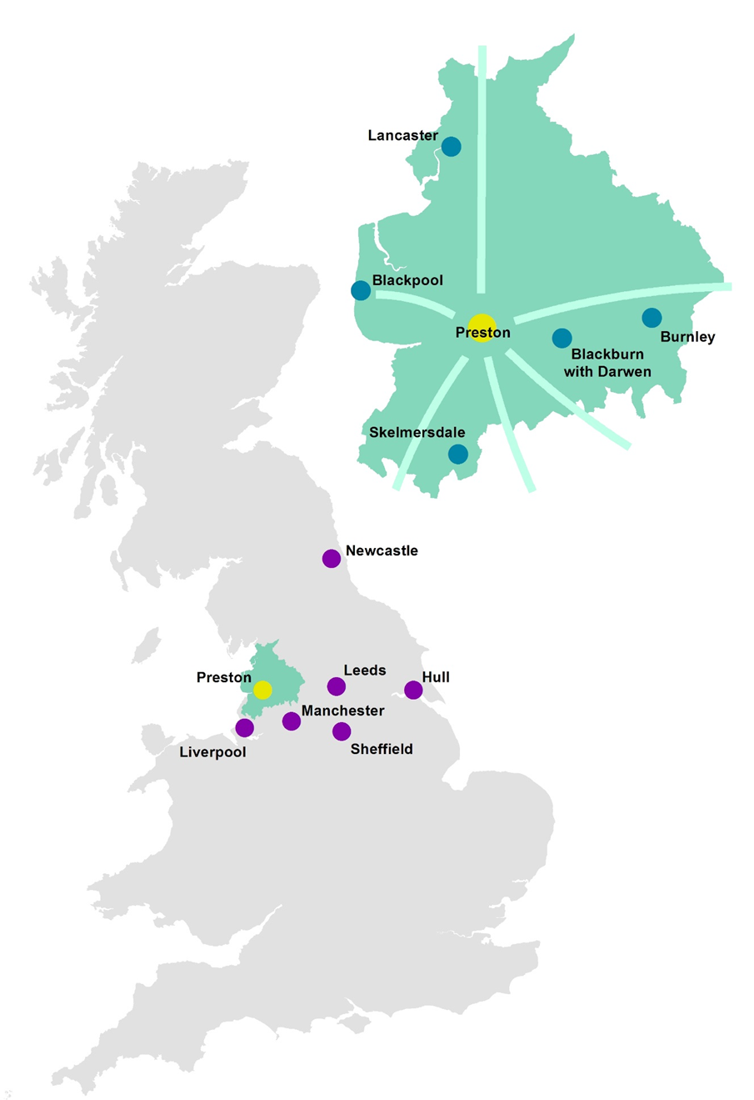

Lancashire’s Integrated Investments – Infrastructure, Housing, Jobs and Skills
Lancashire has benefitted in recent years from key transport and infrastructure investment of national significance such as the West Coast Main Line Route Modernisation programme completed in December 2008. However, apart from the completion of the Heysham to M6 Link Road due to open in summer 2016 and the Pennine Reach public transport scheme in East Lancashire currently being implemented, there has been little investment in critical strategic infrastructure to improve connectivity and support economic growth, development and regeneration. It is estimated that failure to deliver the transport infrastructure needed to support sustained business success accounts for one quarter of Lancashire's current economic performance gap with the rest of the UK.
The Lancashire Enterprise Partnership (LEP) was quick to recognise the importance of transport to the Lancashire economy and the integration of infrastructure investment with business growth and skills requirements is a key feature of the Lancashire approach to maximising the benefits of transport investments.
Indeed, the LEP's nationally recognised City Deal for Central Lancashire, worth over £430m, is centred on a new and enhanced road improvement programme that will develop Preston, its Advanced Manufacturing Enterprise Zone (Samlesbury and Warton) and £200M redevelopment of University of Central Lancashire into one of the fastest growing and commercially dynamic locations in the UK over the next decade.
Lancashire has developed a suite of five Highways and Transport Masterplans covering the entire LEP footprint. These masterplans have ensured that for the first time strategic transport investment across all modes has been aligned with economic development and spatial planning priorities including housing.
The establishment of Transport for Lancashire as a dedicated committee of the Lancashire Enterprise Partnership demonstrates the resolve of Lancashire's three local transport authorities (Lancashire County Council, Blackburn with Darwen Council and Blackpool Council) to work constructively and decisively with the private sector to deliver binding priorities.
TfL, is a dedicated committee of the LEP with responsibilities including:
- Monitoring progress and advising the LEP Board on scheme delivery
- Advising the LEP Board on scheme approvals and investment decision making
- Advising the LEP Board on long-term rail planning and franchise specification and provide a co-ordinating role between constituent local authorities; and
- Advising the LEP Board on long-term Strategic Road Network planning and provide a co-ordinating role between constituent local authorities.

Through the City Deal, the LEP secured a 10-yr local major transport programme, accelerated to a 6-yr delivery programme through the LEP's 2014 Growth Deal for Lancashire. This current transport investment programme comprises:

Scheme | Total Cost | Status
Centenary Way Viaduct Maintenance, Burnley | £1.82m | Under construction
Blackpool Integrated Traffic Management | £2.42m | Funding approval October 2015
Blackpool Bridges Maintenance | £4.23m | Under construction
Blackburn Town Centre Improvements | £0.23m | Funding approval April 2016
Preston City Centre Improvements | £7.00m | Funding approval October 2015
M55 to St Annes Link Road | £15.00m | To be advised
Blackburn to Manchester Rail Corridor | £13.80m | Completed
Burnley – Pendle Growth Corridor | £12.00m | Funding approval December 2015
East Lancashire Strategic Cycle Network | £5.89m | Under construction
Preston Western Distributor | £92.00m | Funding approval December 2017
Broughton Bypass | £24.30m | Funding approval October 2015
Blackpool Town Centre Green Corridors | £7.34m | Funding approval April 2016
Blackpool Tramway Extension | £18.20m | Funding approval April 2017
Darwen East Distributor | £3.00m | Funding approval February 2017

- Lancashire’s Focus on the Future
Having spent many years dealing with the after effects of major industrial decline and dramatic employment losses, Lancashire has set ambitious plans to move to a modern, competitive economy, based on new products and services, trends in living and leisure, innovation and creativity, in a world of both international opportunities and competition.
The Lancashire LEP has embarked on a twenty to thirty year journey to transform the Lancashire economy, building on its many assets, to focus the new economy on sectors and services where market demand is growing and long term prospects are positive. Lancashire’s new economy is based on a world class and competitive manufacturing sector, new opportunities for higher value added service sectors, and the natural and heritage assets that underpin a strong leisure and visitor economy.
The 21st Century Lancashire economy will be a key part of the Northern Powerhouse, characterised by a business base focussed on taking advantage of markets and innovation. The major sectors will include advanced engineering, energy and environment, professional, financial and business services, creative, digital, media and ICT, logistics, and high quality tourism and leisure.
These sectors will be the principal source of wealth generation in the new Lancashire economy, whilst other sectors, such as retail, health, education and transport will provide the services that support strong local economies and communities.
New Economy, New Lancashire
As the new economy of the 21st century increases the emphasis on a well-qualified and skilled workforce, Lancashire’s higher and further education centres are attracting more students, both locally, from elsewhere in the UK and internationally. Lancashire’s new economy will be characterised by businesses which invest in human capital, with close working relationships between businesses, schools, training providers, colleges and universities.
The Lancashire economy, as for many other parts of the UK, needs to attract new skilled labour to support its economic and employment growth plans. New housing will be a key element in delivering economic growth in Lancashire over the next twenty years. Lancashire will provide more housing in popular neighbourhoods and towns, while at the same time, delivering major new housing developments in locations close to the strategic road and rail networks to ensure the scale of new housing needed to support economic growth is delivered.
The new Lancashire will be reflected in the major economic centres including Preston, Blackburn, Blackpool and Lancaster, with improved connectivity within Lancashire and to the other major economic centres of Liverpool and Manchester, and to the east Leeds and York.
Investment in the rail network is leading to better connectivity with Manchester, with a marked improvement in services from Blackburn and Burnley, as well as an increase in services from Preston and Blackpool. These and other investments will strengthen Lancashire’s links to both the Greater Manchester and Merseyside economies.
New investment in the road network in and around Preston will improve access to the City, strengthening Lancashire’s role as the central location between Greater Manchester and Merseyside to the south and Cumbria and Scotland to the north.
From a Ten to a Twenty Year Vision
Lancashire's Strategic Economic Plan (SEP) and Growth Deal aim to re-establish Lancashire as an economic powerhouse and a national centre of excellence in advanced manufacturing and engineering by maximising its clear competitive strengths and capabilities in the aerospace, automotive, energy and Higher Education research related sectors. This will be achieved by focusing on an 'Arc of Prosperity' that extends across Lancashire and incorporates key sector priorities of national and international significance, strategic sites, clusters of high value activity and internationally recognised centres of excellence in research and innovation.
The 'Arc' also incorporates key assets and other sectors including quality of life and housing growth offers, a significant tourism and visitor economy, health, digital and food manufacturing. Supporting this sector and asset development programme is a strategic approach to skills development and business support. The Lancashire LEP has set out its plans for the first stage of the transformation of the Lancashire economy, whilst recognising that the Northern Powerhouse vision, with its connection to services such as High Speed 2, which will begin operating from 2026, are linked to a 20-30 year transformation and growth programme.
Lancashire’s SEP is based on an additional 50,000 jobs over the next ten years (2015-205) through a more competitive manufacturing sector, higher value added service sectors, and a growing visitor and leisure economy, based on the strength of the company base, the skills of the workforce and a great quality of life at an affordable cost. This initial phase will be linked to an outward facing economy making a significant and recognised contribution to a resurgent North of England economy, with civic and business leaders making the case for new investment to further increase Lancashire’s economic contribution to the national economy.
The second phase of growth needs to continue with the employment growth trajectory but to focus overall economic growth on productivity improvements which drive additional GVA. The low levels of GVA/capita, in sharp contrast to the south-east, emphasise the importance of addressing productivity as well as employment growth in long -term strategies.
Northern Powerhouse West GVA/capita England = 100
West | 2013
Cumbria | 83.0
Lancashire | 74.3
Greater Manchester | 88.6
Cheshire and Warrington | 108.9
Liverpool City Region | 76.3
Source: Regional Accounts
Lancashire's economic strengths and growth priorities are a significant part of, and critical to, the shaping and building of the Northern Powerhouse. The Northern Transport Strategy must reflect Lancashire's contribution in order to deliver a powerful, balanced and sustainable Northern Powerhouse.
For Lancashire to maximise its economic potential, it needs to fully exploit its key innovation assets, growth sectors, skills, and transport infrastructure. Lancashire is a county of contrasts with a rich quality of life that distinguishes it from neighbouring city regions and makes it an attractive place in which to live, work and invest, with world-class businesses and access to a highly skilled workforce, strongly performing schools, colleges and higher education establishments, strategic transport networks and effective broadband connectivity.
Lancashire’s economic ambitions are based on more jobs and better jobs and these are reflected in its priorities for transport investment. Capitalising on the strategic location of the county, strengthening links to Greater Manchester and Merseyside, and developing Lancashire's key employment locations are central to accelerating productivity and economic growth over the next twenty years.

Lancashire's Arc Of Prosperity

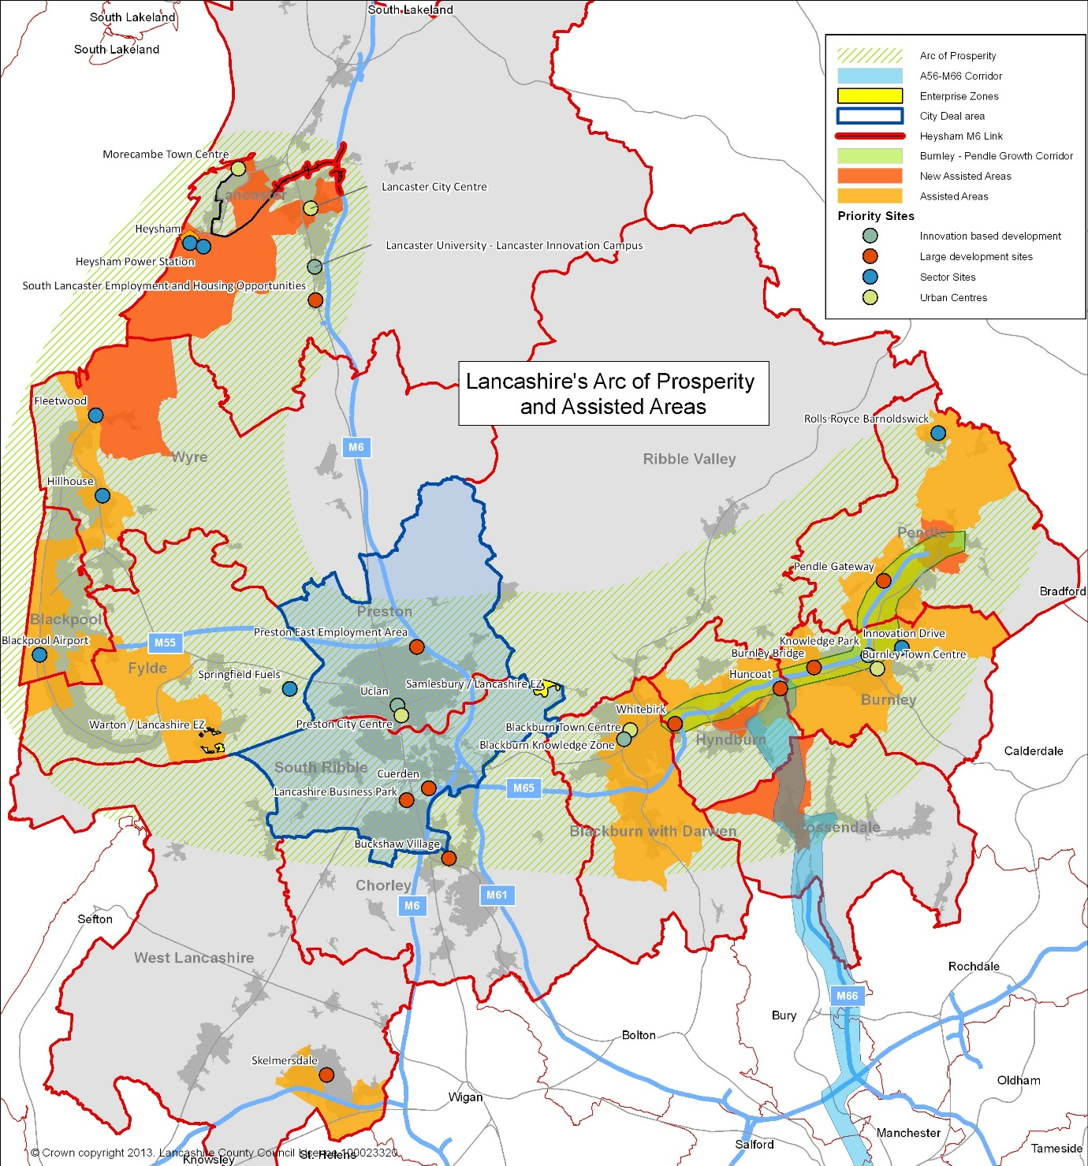

- Delivering Growth Through Transport Investment
The SEP identifies transport connectivity as fundamental to delivering economic growth and potential across Lancashire. However, despite sustained growth in the last decade particularly in identifiable economic 'hotspots' such as the cities of Preston and Lancaster, Lancashire's average performance still consistently lags behind that of the UK and neighbouring city regions. For example, between 2007 and 2011 Lancashire's economy grew by 4.4% compared to 6.5% nationally and 4.9% regionally, meaning Lancashire's GVA per capita was 77% of the UK average. Today the economic performance of Lancashire is more than 20% below the national average in terms of GVA per resident.

Understanding Lancashire’s Complex Economic Landscape
Central and East Lancashire account for over 60% of Lancashire GVA and employment base and both have strong connections to the Greater Manchester economy. Blackpool, Fylde and Wyre is a powerful sub-regional economy with strong connections to Central Lancashire. West Lancashire has strong connections with the Liverpool City Region, and to the north, Lancaster has strong connections to both Central Lancashire and Cumbria.
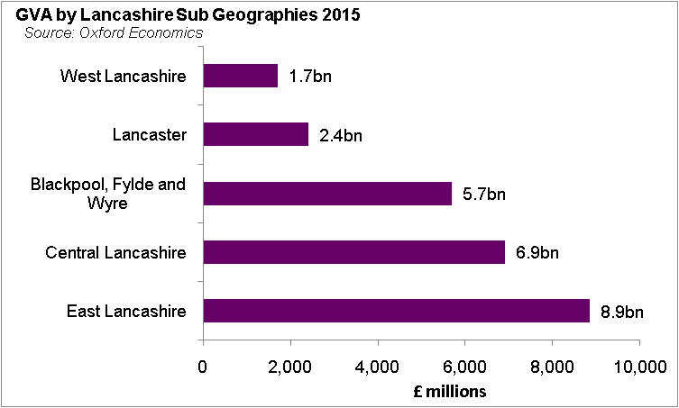 | 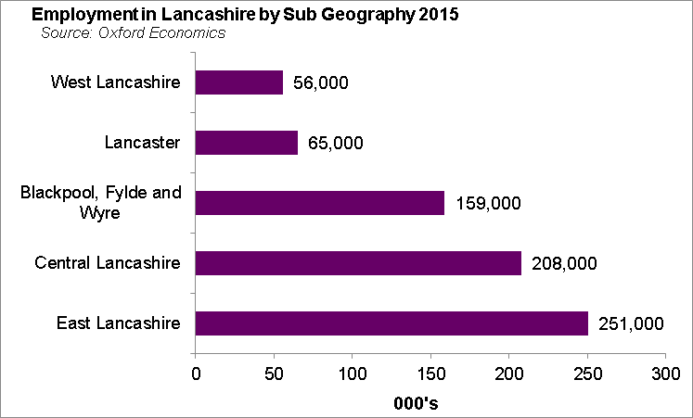
Central and East Lancashire include the two major centres of Preston and Blackburn and accommodate a large part of Lancashire’s advanced manufacturing base. New investments in public realm and roads, along with UCLan's masterplan, are transforming the Preston city centre, whilst recent town centre developments, including a new Cathedral Quarter and railway station, are providing a new platform for growth in Blackburn.
Central Lancashire, with Lancashire's principal city Preston at its heart, is a transport hub of national significance, providing most of the county's connections to the West Coast Main Line, the M6 and, in the future, to HS2. The Preston, South Ribble and Lancashire City Deal builds on the strong economic performance of the area over the last ten years and will see Central Lancashire transformed, creating 20,000 net new private sector jobs and delivering over 17,000 new homes, underpinned by significant investment in new and improved transport infrastructure. Whilst Lancashire's growth sectors will account for many of these jobs, in particular, at the Enterprise Zone sites at Samlesbury and Warton, Preston's business and financial sector will also expand, with the University of Central Lancashire reconfiguring to place itself at the heart of the city. It will be vital to existing and new business, whether based in Central Lancashire or further afield, that accessing Lancashire is straightforward and not compromised by problems on the rail and strategic road networks elsewhere across the North.
East Lancashire, centred on Blackburn and Burnley, has a growing portfolio of higher value industries with aerospace, advanced manufacturing, advanced flexible materials, digital and creative industries all featuring strongly in the area's economy, making its improved economic prospects key to both the success of the Lancashire Enterprise Zone and the Northern Powerhouse. With easy access to high quality rural areas including the Forest of Bowland Area of Outstanding Natural Beauty, East Lancashire also has the potential to become a sought after place of residence for commuters. However, the quality of many local rail services and infrastructure leaves much to be desired, hence there is a significant identified requirement for greatly enhanced rail connectivity, with higher speeds, greater frequency and better rolling stock quality to enable East Lancashire to contribute to Lancashire's growth and that of neighbouring city regions such as Manchester and Leeds. East Lancashire's motorway gateways are pivotal in supporting our ambitions, for Lancashire as a whole and for its role in the wider economy of the North.
Lancashire’s west and coastal areas include an outstanding environment and some of the most attractive areas to live in the north of England. There is a diverse range of major centres including Blackpool, Lancaster and Skelmersdale, with strong manufacturing and business and professional service centres.
Blackpool and the Fylde Coast the economic renewal of Blackpool is key to the growth plans for the Fylde Coast. The wider area containing towns and rural communities popular with commuters, with the advanced engineering and manufacturing sector providing highly paid jobs that underpin local economies. With the nationally significant resort of Blackpool central to the area and a visitor economy that is revitalising supported by recent investment, leisure and tourism are important components of the Lancashire economy. The LEP has worked with Government and local partners on its proposal to establish Blackpool Airport as Lancashire's second Enterprise Zone to establish another focal growth point.
Lancaster is home to one of the country's top teaching and research institutes: Lancaster University is in the top 1% of global universities. The emphasis on research makes Lancaster a key hub for innovation, and with major expansion proposed at and around the University connectivity for business and academia is of particular importance. The district is also home to the major port of Heysham, a key facility for Irish Sea Ro-Ro traffic between the UK mainland and Ireland and the Isle of Man. Completion of the £130m Heysham to M6 Link Road in the summer of 2016 will significantly improve the port's access to the M6, but for the port to reach its full potential, the Strategic Road Network across the North must be effective. The district makes an important contribution to the visitor economy and is the seat of the Duchy of Lancaster and a prominent gateway to the Lake District and beyond.
West Lancashire is home to a number of international and nationally recognised companies and Edge Hill University. Located between the major growth areas of Manchester, Liverpool and Central Lancashire, the area already provides an attractive location for logistics and distribution companies. Skelmersdale is particularly well-placed to build on its locational strength and take advantage of the opportunities presented by the development of the Liverpool SuperPort concept, a key priority for the Liverpool City Region Strategic Economic Plan. The Atlantic Gateway initiative, a collection of assets including transport infrastructure that represents an opportunity for growth, lies just to the south.

- Lancashire's Priorities

Lancashire's suite of five Highways and Transport Masterplans have identified the national and local strategic transport priorities to improve connectivity and support economic growth, development and regeneration. If fully implemented these schemes will deliver (the summary numbers)

The Northern Transport Strategy - Lancashire's National Strategic Priorities

The following national strategic priorities are integral to the long term transport strategy for the North and will ensure that Lancashire, as one of the North's most significant sub-national economies, continues to prosper and support the vision and objectives of the Northern Powerhouse.
Lancashire plays an important role in the UK's national transport infrastructure with key rail and road connections across the North and to Scotland, the Midlands and the South. It is closely linked to the Greater Manchester economy, which continues to be the key economic driver for the Northern Powerhouse and strategic hub for east west connectivity across the North.
Lancashire's National Strategic Priorities
Strategic Objective | Investment Priorities
Increase productivity and growth in the Northern Powerhouse West economy through strengthening north-south road and rail infrastructure | HS2 and the West Coast Main Line  Preston Railway Station  M6 Motorway
Increase productivity and growth in the Northern Powerhouse West economy through strengthening connectivity between Lancashire and Greater Manchester | The Preston to Manchester Rail Corridor  M61 Motorway

HS2 and the West Coast Main Line / Preston Railway Station
Preston lies approximately mid-way between Glasgow and London on the West Coast Main Line, and also has regular direct services to Manchester, Manchester Airport, Birmingham, Edinburgh, Leeds and Liverpool, as well as providing connections into these services from Blackpool, Blackburn and East Lancashire, Lancaster and the Lake District. The railway station is a critical asset for the city and for Lancashire as well as serving as a gateway for communities further afield, particularly for connectivity to the West Coast Main Line. With over 4.5 million passenger users annually and a further 1.3 million interchanges, Preston is the busiest station in the North West outwith Manchester and Liverpool city centres and one of the busiest in the North.
As a key economic centre in its own right and identified by Government as such, it is vital that Preston has direct and frequent access to HS2 and any potential HS3 in fit for purpose surroundings. The existing station track layout comprises six operational through platforms and two bay platforms; none of the through platforms will be capable of accommodating HS2 trains. Furthermore, the station fabric has seen little investment in recent years, resulting in a poor passenger experience and preventing the station from contributing towards the wider commercial development of the city centre. The station must therefore be transformed into a modern, 21st Century facility, one that is fully HS2 compatible to maximise the inherent advantages of Preston's location on the national rail network and through which passengers can pass in comfortable surroundings. Such a transformation will have secondary benefits, enhancing the station's presence within the city centre and its relationship to existing and proposed development, including the £200m UCLan campus redevelopment and the leisure-led transformation of City Centre North, home to Preston's other major transport hub, the bus station.
The significance of Preston Station as a driver of economic growth is recognised by stakeholders both within and outside Lancashire. As such, the station's development is of fundamental importance to the economic growth aspirations across Lancashire, and in so doing, particularly once HS2 becomes operational, will reinforce Preston's role as the North West's major rail hub north of Manchester. Establishing an HS2 Growth Strategy as recommended by the HS2 Growth Taskforce for Preston will be an important element to achieving this. In addition, Network Rail has requested the City and County Councils prepare a long term vision for the station to inform its strategic review of West Coast Main Line capacity north of Crewe. The County Council has commissioned Mott Macdonald to prepare an outline masterplan for Preston station as the first stage towards an HS2 Growth Strategy.
From a Lancashire perspective, whilst the recommendation from Sir David Higgins to accelerate delivery of an HS2 Hub at Crewe in 2027 rather than 2033 as originally planned is welcomed, it is essential that a connection from HS2 to the West Coast Main Line further north is retained. The recommendation to review this connection in light of concerns raised through consultation is noted, as is Sir David's assertion that such a link will be necessary sooner rather than later as part of the wider consideration of how to improve services to Scotland. Lancashire also wishes to see this link considered in conjunction with the proposed wider examination of east-west connectivity across the North including HS3, the proposed new Trans-Pennine rail connection linking Manchester with Leeds and Sheffield.
Work carried out for High Speed 2 provided estimates of the benefits of HS2 to sub-regional economies, with those sub-regions with poorer connectivity to London benefiting more. In total, the HS2 Y network to Manchester and Leeds is expected to generate £15bn of productivity benefits. Estimates for northern city region stations are:
High Speed 2 Regional Economic Impact
 | Productivity Gains | Commentary
Greater Manchester | £0.6bn - £1.7bn | Equivalent to between a 0.8% and 1.7% increase in total local economic output in 2037.
West Yorkshire | £1.0bn | Equivalent to a 1.6% increase in total local economic output in 2037.
South Yorkshire | £0.5bn-£0.9bn | Equivalent to between a 1.9% and 3.2% increase in total local economic output in 2037.
Source: High Speed 2 Regional Economic Impact, KPMG 2013
Over half of the £15bn impact of HS2 will be outside of the HS2 station sub-regions. Lancashire will benefit from new rail infrastructure and service improvements, and a provisional estimate of productivity gain would be of a similar scale to South Yorkshire at circa 2%, equivalent to £600m in 2037 at today’s prices.
Some 40% of the productivity benefits are likely to be captured in the Preston/South Ribble economy, which currently has some 162,000 jobs and a total GVA of £5.3bn. It is likely that up to half of the productivity gains will be a result of increased productivity in existing jobs, with the other half creating new, additional jobs. This would suggest a local employment impact of some 3,000 additional jobs.
Work carried out by Jacobs has indicated significant journey time benefits valued at £10m per annum and 75,000 net additional visitors, which will add some £3.3m to the Preston economy each year.
Preston Station Regeneration Benefits
There are two elements to the economic regeneration benefits of Preston Station. These are:
- Station and other 'Near to Station' developments; and
- Preston New Business District.
Station and other 'Near to Station' developments will provide new retail, leisure and hotel opportunities, which will add to the city centre offer. In addition, there is the potential for office development linked to the transformed station, the concourse of which would be elevated to street level as part of re-development plans. A number of specific sites have been identified, with planned development evenly balanced between retail and leisure/commercial space.
Preston New Business District is a new opportunity to develop the area immediately to the north of the station and bounded by Ringway. This scale of development is the Preston equivalent of, and similar to, plans for the Piccadilly area in Manchester and the Leeds South Bank.
The New Business District would provide Preston with the high quality public realm, mixed use and large floor plate offer currently missing from the city centre (and from Lancashire). The area will provide a new quantum of high quality space, acting as the premium business investment location in Lancashire. It will extend the footprint of the city centre to the north of the station, and elevate the Preston economy to a new level.
The scale of floors pace would have a considerable impact on the city centre economy and further accelerate employment growth. It would in effect act as a further boost as the City Deal's economic momentum comes to an end. Whilst there would be retail/hotel and leisure development relevant to the visitor economy, the major impact would be the new, high quality office space and the impact on professional, financial and business services, together with ICT, digital and creative industries' companies.
Preston Station: Regeneration Impact
 | Retail/ Hotels/Leisure |  |  |  | Office
 | Space m² | Jobs  FTE | GVA  £m | Space m² |  | Jobs  FTE | GVA  £m
PNBD | 10,000 | 250 | £8m | 129,366 |  | 5,174 | £222m
S&ONTS | 38,809 | 970 | £31m | 36,147 |  | 1,456 | £63m
Source: Mott McDonald and BE Group
The total economic impact would be considerable, a total of 7,850 FTE jobs (equivalent to over 10,000 full and part time jobs) and £324m in GVA over the coming decades.
Housing
Housing to support economic growth is now an important objective for Lancashire. In simple terms, new housing is required to attract the skilled workforce necessary to support the growth of the priority sectors. Additional employment generates in-migration and new housing needs to accompany and not lag behind employment growth.
Preston’s redeveloped station will increase local employment and generate demand for sites near to the station. It will also increase demand in a wider area for people keen to live close to where they work or near to the station for those commuting to other major employment centres.
Utilising the Housing Zone designation from Government in 2015 some 32 sites will be influenced by the development of the new station, of which over 14 have the capacity to provide 1,000 homes/apartments within one mile of the station.
The new housing developments will allow Preston to modernise its housing offer and to provide city living apartments for younger people, and new urban neighbourhoods for professionals and their families.
The Preston Station/HS2 proposal will provide Preston and Lancashire with a twenty year growth scenario, with the City Deal driven employment growth of 20,000 additional jobs by 2025 overlapping with an additional 10,000 jobs from the regeneration opportunities provided by the transformed station over the period from 2022 to 2032, and an additional 3,000 additional jobs (and productivity improvements) by 2037 from HS2 operations.
The housing impact from the City Deal and Preston Station transformation would meet the local demand from the scale of employment benefits outlined in the three phases of growth, with the circa 4,000 new homes in Preston from the station re-development providing local housing for a significant proportion of the 10,000 additional jobs in the city centre and new business district.
The additional economic impact would transform Preston into one of the fastest growing cities in the North of England, with a higher education, leisure and retail and business services economy to compete with the UK’s leading cities.
The M6 Motorway
The M6 is an integral part of the UK’s main north-south transport spine between London, the West Midlands and Scotland, which also includes the West Coast Main Line. From a Lancashire perspective, it is particularly important for the movement of freight, for example, to and from the Port of Heysham, and for logistics and distribution companies located in Central Lancashire and Skelmersdale. South of Preston, deterioration in the operational effectiveness of the route is resulting in increased average journey times and a worsening of journey time reliability. Lancashire therefore welcomes the commitment in the Road Investment Strategy to upgrade much of the M6 south of Junction 26 (the M58 west of Wigan) to Smart Motorway by 2019/20.
Even with full delivery of the schemes set out in the Central Lancashire Highways and Transport Masterplan, evidence suggests that the M6 Preston Bypass will be under pressure by 2026, particularly during peak periods between Junctions 30 and 32 with the M61 and M55 respectively. This length of the M6 already has four lanes in each direction, so 'Smart Motorway' technology as a potential solution will need assessing. Possible scheme elements could include access controls at junctions and variable speed limits. For consistency, Lancashire proposes that the 'smart spine' linking the North West and London referred to in the Road Investment Strategy be extended from Junction 26 as far north as Junction 32.
The Preston, South Ribble and Lancashire City Deal has set out ambitious plans for new commercial and residential development. One of the legacies of City Deal investment is a long term land supply to support the economic ambition set out in the Strategic Economic Plan. Many of the key long term opportunities are close of the M6 and there is a risk that constraints at key junctions or capacity will constrain new development.
The City Deal Infrastructure Delivery Plan 2015/18 highlights six development areas. These are set out below, along with the key junctions on the Strategic Road Network which impact of each area.
Preston and South Ribble Development Areas
Zone | Key Junctions
Preston City Centre | M6 Junctions 29 & 31; M55 Junction 1
North East Preston | M6 Junction 31a
North West Preston | M55 Junction 1
Penwortham and Lostock Hall | M6 Junction 29
Bamber Bridge | M6 Junction 29
Leyland and Cuerden | M6 Junctions 28 and 29
It will be important that potential capacity constraints on the M6 in particular are anticipated in advance of increasing demand for new sites and employment locations, including in the medium term, ie post 2020 and post 2025.
The City Deal provides the capacity for over 1m² of commercial space, with two thirds delivered by 2014. . The scale of employment is considerable, circa 20,000 jobs, and City Deal infrastructure should allow most development to come forward.
From 2025, there is the potential for further employment growth in Preston and South Ribble, with an additional 20,000 jobs. This growth will continue the momentum established by the City Deal, with a number of major locations providing for new and additional employment land and commercial development. This second phase of growth is likely to present further challenges for the Strategic Road Network and the M6 in particular.
The economic and employment plans of both the City Deal and the Strategic Economic Plan envisage high levels of growth over the next ten and twenty years. With an ageing workforce, Lancashire requires to support a consistent level of in-migration to provide a workforce to support these growth plans. This requires a higher level of housing completions over a sustained period, compared to the (low) development levels of the past five years.
The Preston to Manchester Rail Corridor
The rail corridor linking Preston with Manchester city centre and Manchester Airport is not only of strategic importance to much of Lancashire but also to Cumbria and Scotland. Stations in central Manchester provide connections for onward travel to and from a range of other key destinations across the North, including Leeds and Sheffield. The transport strategy for the North therefore needs to reflect this. In addition, recent economic and employment growth in Lancashire has been strongest in this corridor, with parts of Central Lancashire in particular seeing strong employment growth. It is also the corridor with the greatest opportunity to grow the business travel market in Lancashire and in tandem to help reduce congestion on the parallel M61.
The Northern Hub, due for completion in 2018, will address capacity and network constraints on the rail network in and around Manchester and, when considered alongside completion of electrification between Manchester / Liverpool and Preston / Blackpool North by December 2016, will deliver a significant improvement in terms of connectivity and capacity in the key corridors linking parts of Lancashire with Manchester and Liverpool city centres and Manchester Airport.
Modern electric trains have already been introduced on Trans-Pennine Express services between Scotland and Manchester Airport, which currently travel via Wigan North Western. However, although there are on average four trains per hour between Preston and Manchester (three serving Piccadilly and one Victoria) throughout the working day there is significant overcrowding, particularly on services linking Scotland / Cumbria / Blackpool North with Manchester Piccadilly and Manchester Airport. In January 2015, the Government announced more diesel powered carriages for selected services in the corridor, but these are of a much lower quality than the rolling stock currently operating Trans-Pennine Express services between Blackpool North and Manchester Airport.
Travel times for the journey between Preston and Central Manchester currently range from 40 minutes by the fastest trains to 56 minutes by the slowest; electrification will see the line speed raised up to 100 mph in places and the quickest journey times reduced to nearer 30 minutes as a consequence. However, it will be essential to ensure that the advantages electrification will deliver in terms of improved quality of service are not eroded through failure to provide sufficient capacity both in terms of length of train and service frequency.
Increased capacity in the Preston to Manchester Rail Corridor will contribute to the economic growth plans of Preston/South Ribble and Chorley, allowing employers access to a much larger pool of labour and also enabling residents to access employment markets in Greater Manchester, including Manchester city centre and Salford Quays. It will have a direct implication for housing development, and for new housing within travelling distance of stations in the corridor. In simple terms, each new commuter generates an additional housing demand, either directly as they move into Lancashire while commuting out to work, or indirectly as they leave a local job to commute, which then leads to in-migration demand as their post/job is filled.
The Greater Manchester Economic Forecasting model indicates that employment in Greater Manchester will increase by 100,000 additional jobs over a ten year period. The forecasts also indicate that there will be a change in the composition of the workforce, requiring it to be more highly educated and better qualified. This is particularly true for the city centre economy. These employment and skills forecasts will result in the conurbation drawing its labour force from a wider economic geography, hence increased train capacity will have an important role to play in ensuring that growth in the workforce is accompanied by increased commuting using sustainable modes of transport.
The current levels of commuting from the three Central Lancashire local authorities into Greater Manchester are set out below, and are likely to increase as new housing development and better rail services provide a high quality lifestyle offer in Central Lancashire. While commuting levels are significant, the limitations of services at local stations tends to restrict the scale of rail commuting.
Out-Commuting
Residence | Work in Greater Manchester 2011¹ | Commuting  By Rail² | Passenger Growth³
Preston | 2,180 | 271 | 8%
South Ribble | 2,567 | 244 | 8%
Chorley | 7,162 | 577 | 8%
In Commuting From GM | Working In
Preston | 3,841 | 349 | 8%
South Ribble | 3,068 | 33 | 8%
Chorley | 4,576 | 99 | 8%
¹ 2011 Census data
³ Estimate of increase in working commuters traveling by train, post capacity increase.
The additional working out-commuters as a result of GM employment growth and improved services would generate a housing requirement (after allowing for existing commuters switching to rail), adding to housing demand in South Ribble and Preston, allocations of which are based on providing sufficient housing to support planned employment growth, including the 20,000 City Deal jobs. Providing additional capacity in the Preston to Manchester Rail Corridor will increase the pool of labour available to support economic and employment growth in Central Lancashire, including the City Deal growth plans of 20,000 additional jobs by 2025 and subsequent employment growth arising from the Preston Station/HS2 development.
The skills evidence base has highlighted the challenge for Lancashire in providing the skilled workforce necessary for the growth plans of many of the priority sectors (including advanced manufacturing, construction and professional and business services). Given the very limited new housing development in recent years and the pace of new housing completions, in-commuting will be required to support the economic and employment growth set out in the Strategic Economic Plan.
Each additional commuter adds value to the local economy, and in the priority growth sectors in-commuting from Greater Manchester will be essential to economic growth in Lancashire. Additional capacity in the Rail Corridor is likely to increase in-commuting and result in an important GVA contribution. In the medium term, increased in-commuting is likely to increase demand for housing as people tire of travelling or prioritise reduced travel times and the opportunity to live closer to employment. This additional demand factor is, however, likely to be implicitly considered within the housing plans sets out in the City Deal and local development plans.
M61 Motorway
The M61 links the M6 at Preston with the M60 Manchester Outer Ring Road and the Trans-Pennine M62. Although existing traffic flows are generally within the capacity of the road, the M61 Corridor is heavily used by commuters, and significant congestion with long queues of standing traffic occurs during the morning peak period on the southbound approach to the M60 at Junction 15 as traffic attempts to access Manchester City Centre via the A580 and other destinations via the M60.
Lancashire therefore has a strategic interest in the operational effectiveness of the M60 as this provides access to and from Manchester Airport via the M56 and Yorkshire and eastern England via the M62. Consequently, the Manchester North West Quadrant Study announced in the Department for Transport's Road Investment Strategy is of particular interest to Lancashire.
East – West Connectivity
There is growing interest in the east-west transport corridor linking Central Lancashire with North Yorkshire and the Leeds City Region focused on the M65 and A59 and parallel rail routes. Several long-standing aspirations for improved connectivity by both road and rail currently exist and a number of schemes have been considered in the past. The corridor is not covered by any of the Department for Transport led studies announced in the Road Investment Strategy in December 2014. Discussions are in hand with the Department for Transport and neighbouring transport authorities to identify whether there is sufficient justification to undertake a strategic connectivity study in the corridor.
Road links in this corridor tend to follow historic routes dictated by topography rather than travel demand; most are poorly aligned and unsuitable for carrying large volumes of traffic, particularly heavy goods vehicles. Main line rail links are likewise constrained by topography, with resulting low line speeds having a significant impact on journey times. Both are of a much lower quality than those further south that link Liverpool and Manchester with Leeds, Sheffield and the Humber ports. Consequently, there is a strong perception locally that the transport network hinders the efficient movement of people and goods, and that this poor connectivity is having a negative impact on economic development and regeneration, in East Lancashire in particular.

Lancashire's Local Strategic Priorities - Connecting Lancashire to City Region Networks

The Northern Transport Strategy is not just about travel between cities, it also includes the development of city region rail networks that provide the additional capacity required to sustain economic growth. These networks will interconnect with HS2, new intercity services across the North and metro/tram systems, supported by much expanded park and ride facilities.
Strengthening links to the major city regions will require electrification, new rolling stock (a matter of urgency for the North in terms of quality and sufficiency), higher service frequencies, new services and the removal of network pinch points. Development of European style cross city region networks centred on hub stations, such as Preston, is a key aspiration.
Connecting Lancashire to City Region Networks
Strategic Objective | Investment Priorities
Increase productivity and growth in the Northern Powerhouse West economy through strengthening connections to the major City Region economies. | East Lancashire to Manchester City Region, Leeds City Region and Central Lancashire  Skelmersdale to Liverpool City Region and Manchester City Region  West Lancashire to Liverpool City Region and Central Lancashire
East Lancashire
In East Lancashire, a number of improvements to the rail network have either been delivered or are programmed, including the recently completed upgrade to Burnley Manchester Road station and the introduction of a new direct train service between Blackburn, Accrington, Rose Grove, Burnley and Manchester Victoria via Todmorden and Rochdale in May 2015. Network Rail has recently completed a scheme to improve the reliability and frequency of rail services on the route between Clitheroe, Blackburn and Manchester Victoria, funded through the Lancashire Enterprise Partnership's transport investment programme. The scheme will facilitate provision of an all-day, half hourly service between Blackburn and Manchester to be delivered through the new Northern franchise. Currently, a firm date for the commencement of the additional off-peak services has not been finalised, but it will be no later than December 2017 utilising rolling stock made available through the North West electrification programme.
Whilst the above developments will bring about some improvement to the rail network in East Lancashire, they will not address the fundamental issue of whether or how the rail network can contribute towards a transformational change in East Lancashire's economic fortunes. The East Lancashire Rail Connectivity Study has examined this issue in depth, in particular, the importance of enhanced connectivity between East Lancashire and the growth centres of Preston and Central Lancashire, Manchester including Manchester Airport, and Leeds.
The Connectivity Study identified a number of deficiencies with the current network, including:
- Slow journey times, especially on the 'Copy Pit' line between Burnley and Todmorden used by the train service between East Lancashire and Leeds and from May 2015, the new service between East Lancashire and Manchester Victoria via Rochdale;
- Poor reliability due to long, single-track sections, for example, between Burnley and Colne;
- Capacity constraints, with longer trains required to meet growing demand, in particular, on commuter services between Clitheroe and Manchester;
- Low service frequencies;
- Poor quality rolling stock; and
- A lack of facilities at many of the smaller stations, which will need to meet as a minimum the Station Quality Standards set out by Rail North.
All of the above make rail a less attractive mode of travel; consequently, use of the rail network in East Lancashire is relatively low compared to neighbouring areas, including between East Lancashire and neighbouring city regions.
The Connectivity Study concluded that significant investment will be necessary in order to improve both the performance and attractiveness of East Lancashire's rail network, and that without such investment, the perception of East Lancashire as a poorly connected area is likely to grow. Failure to improve or replace existing rolling stock is likely to lead to further deterioration in the quality of the trains, potentially impacting on journey quality, capacity and performance.
The Connectivity Study adopted a Conditional Outputs approach in accordance with standard rail industry practice, recognising that to deliver transformational change to East Lancashire's rail network will require as a minimum the support of Network Rail, Rail North and the relevant Train Operating Companies. Whilst the realisation of each output will be subject to the identification of an affordable and value for money solution, the study concluded that electrification of the routes between Preston and Leeds / Colne and Clitheroe / Blackburn and Bolton together with associated rolling stock improvements would make the most significant contribution. Inclusion of the full 'Calder Valley', which includes the route between Preston and Burnley, and the Bolton to Clitheroe route as Tier One schemes in the report of the North of England Electrification Task Force with a recommendation for implementation in Control Period 6 (2019 to 2024) is therefore a most welcome development.
Skelmersdale
Whilst Skelmersdale enjoys excellent strategic connectivity to the Strategic Road Network via the M58, access to both Liverpool and Manchester is limited; it is one of the largest towns in the country without a town centre railway station. The nearest railway station, Upholland, is not easily accessible without a car and only served by an hourly train service to Kirkby and Wigan, and bus services are slow and journeys indirect.
The West Lancashire Highways and Transport Masterplan, adopted by Lancashire County Council in October 2014, is proposing the wholesale reconfiguration of Skelmersdale's transport networks to meet both current and future needs, not just for local residents and businesses but for West Lancashire as a whole. At its heart is a new rail link and town centre railway station, fully integrated with the bus network and easily accessible on foot or by cycle, and with sufficient car parking provision to function as a 'Parkway' station for the wider West Lancashire area. A new railway station could act as a direct stimulus in terms of employment and housing development, allowing the town to benefit from its proximity to these two major employment centres. Skelmersdale would be served by a new spur from the existing Wigan Wallgate to Kirkby line into the town centre, enabling through services to operate to both Liverpool (via Kirkby) and Manchester (via Wigan), providing direct access to growth opportunities in both city centres and potentially at Manchester Airport and the Airport City Enterprise Zone. The new station and interchange is also intended to act as a catalyst for the wider redevelopment and growth of the town centre.
Lancashire County Council and its partners Merseytravel and West Lancashire Borough Council commissioned Network Rail to undertake a GRIP Stages 1-2 (Guide to Rail Investment Process - output definition / feasibility) study to develop the proposal set out in the masterplan, including indicative costs. The County Council separately commissioned Jacobs UK limited to undertake an assessment of the likely value for money and wider economic benefits of the proposal commensurate with a Strategic Outline Business Case and the Assurance Framework of the Lancashire Enterprise Partnership.
Work undertaken to date has demonstrated that it is technically feasible to construct a heavy rail link into Skelmersdale town centre in the corridor identified in the West Lancashire Highways and Transport Masterplan, and that the project could deliver value for money. It is therefore a viable proposal. The next stage in the project development process is GRIP Stage 3 (option selection) the main output being determination of a single option and securing stakeholder approval. The Skelmersdale Rail Link features in the LEP's Strategic Economic Plan and the Liverpool City Region Long Term Rail Strategy published in August 2014.
West Lancashire
Merseyrail currently operates a fast and frequent service between Liverpool and Ormskirk using electric trains. However, onward travel to Preston requires a change of train to a diesel-operated service that is infrequent and run to an irregular timetable. Rolling stock quality is also poor. Electrification of the Ormskirk to Preston route with appropriate infrastructure enhancements would resolve the majority of issues, significantly improving connectivity between Preston, West Lancashire and the Liverpool city region. In addition, there is the potential to provide better interchange between Liverpool-Ormskirk-Preston and Manchester-Wigan-Southport services at Burscough. Both are aspirations in the Liverpool City Region Long Term Rail Strategy published in August 2014.

Lancashire's Local Strategic Priorities - Supporting Economic Growth, Development and Regeneration

An important element of transport investment in Lancashire is strengthening the connections between and within the five sub-areas, including linking the west of the county with Central Lancashire/Preston through to Greater Manchester.
Each of the sub-areas makes an important contribution to the £25bn economy, and all have growth plans and potential which will contribute in aggregate to the economic contribution of Lancashire to the Northern Powerhouse.
Supporting Economic Growth, Development and Regeneration
Strategic Objective | Sub Region | Investment Priority
Increase productivity and growth in Lancashire sub regions through investing in transport infrastructure that increases employment and residential land supply, economic growth and the efficient movement of goods and people. | Central Lancashire | New Ribble Crossing
 | East Lancashire | M65 East Lancashire Gateway  M66 East Lancashire Gateway
 | Blackpool and Fylde | Blackpool North Interchange  South Fylde Line  A585 Corridor
 | Lancaster | Lancaster South  Morecambe

Central Lancashire
New Ribble Crossing
The Central Lancashire Highways and Transport Masterplan included a longer term (post 2026) proposal to construct a new crossing of the River Ribble to link together the Preston Western Distributor and the South Ribble Western Distributor via a completed Penwortham Bypass to provide a continuous dual carriageway route between Cuerden and the M55 to the west of Preston. Delivery of these schemes has been accelerated through the Preston, South Ribble and Lancashire City Deal; therefore, the County Council and partners have begun to investigate whether a new crossing could progress more quickly and how such a project might be funded.
East Lancashire
M65 East Lancashire Gateway
The M65 plays an essential role in the economy of East Lancashire, connecting people and businesses internally as well as providing the primary means of access to Central Lancashire and the M6, particularly for freight. Unlike most motorways, the M65 is not three lanes throughout its length, with reduced capacity on some sections, particularly between the M61 and Junction 6 at Whitebirk. Traffic has grown consistently by around 4% per annum since the motorway's completion in 1997, and evidence now suggests that the current level of demand at peak times is causing congestion, with some junctions at or near capacity.
The predominantly two lane section between the M61 and Whitebirk is increasingly likely to become a bottleneck, reducing the ability of the M65 to function as a major gateway to East Lancashire. Through the East Lancashire Connectivity Study, Lancashire County Council and partners are investigating whether and when additional capacity on the M65 between the M61 and Whitebirk might become necessary and how it might be provided. This work is expected to conclude by the end of 2015.

M66 East Lancashire Gateway
As part of the East Lancashire Connectivity Study, Lancashire County Council and partners are undertaking a study to examine the importance of enhanced connectivity in the M66 corridor to Rossendale and the rest of East Lancashire and to identify how best to achieve this enhanced connectivity if there is demonstrable evidence that investment will deliver significant wider economic benefits for East Lancashire and Rossendale in particular.
The study scope includes the Strategic Road Network and relevant routes into Manchester city centre, the 'Metrolink' line between Bury and Manchester Victoria and the national rail network between Rochdale and Manchester Victoria. The study is also considering what form a commuter rail link between Rawtenstall and Manchester could take, as there are a number of potential solutions to rail provision in the corridor.
Given the concern locally that congestion in the M66 corridor is now acting as a constraint on economic growth and social opportunities, the study is also assessing the wider economic, social and distributional benefits and Gross Value Added uplift of any potential transport investment. The study is expected to conclude in autumn 2015.
Blackpool and Fylde
Blackpool North Interchange
Blackpool's new central business district development (Talbot Gateway) is located adjacent to Blackpool North station, the new offices opening up opportunities for commuting by rail. Blackpool North is also the key gateway to the resort for longer distance travellers, but for such a major arrival point, the actual experience on offer is not good.
The Tramway is to be extended from the Promenade to the station, significantly improving public transport connectivity for both residents and visitors. Seamless interchange between the rail network and the tram system will be achieved, providing rail-borne access between the railway station with its newly electrified trains and the Fylde Coast’s tourist attractions and hotels. It is therefore essential that a high quality, multi-modal transport interchange be established at this vital location in support of wider interventions set out in the Lancashire Growth Plan for the renewal of Blackpool.
South Fylde Line
The Fylde Coast Highways and Transport Masterplan identifies the South Fylde Line (Blackpool South to Kirkham and Preston via Lytham St Annes) as a key weakness in the Fylde Coast public transport network. The potential of the line could increase significantly if possible connections with the Blackpool Tramway are considered. Lancashire County Council is a partner in the European SINTROPHER (Sustainable Integrated Tram-based Transport Options for Peripheral European Regions) project. The Council secured funding to investigate the best way of enhancing the role of the South Fylde Line in providing a southern gateway to Blackpool and to establish what the most viable and cost-effective way of linking the South Fylde Line and the Blackpool Tramway might be and what benefits such a link might deliver. The study reported in September 2015. It considered a number of options for developing the route and for encouraging economic growth in the South Fylde and regeneration, particularly in parts of south Blackpool. Two potential high value for money interventions have been identified and the County Council is now considering how these could be taken forward.
A585 Corridor
The A585 between the M55 and Fleetwood is currently part of the Strategic Road Network and therefore managed and maintained by Highways England. Its strategic role as part of an inter-regional route between Great Britain and Northern Ireland ceased with the withdrawal of the Ro-Ro ferry service from the Port of Fleetwood to Larne in December 2010. The A585 nevertheless remains a key route within the Fylde Coast highway network and is vital to the regeneration of Fleetwood and the success of the Hillhouse International Business Park at Thornton.
As part of its Pinch Point Programme, in 2014/15 Highways England completed significant improvements at the A585/A586 'Windy Harbour' junction near Singleton and the A585 junctions with Bourne Way and West Drive between Thornton and Cleveleys at a combined cost of £3.1m. Congestion nevertheless remains an issue at a number of other locations, in particular, the Five Lane Ends traffic signals at Little Singleton, which is arguably the worst remaining bottleneck on the on the route and a difficult location at which to make a significant improvement. The Department for Transport's Roads Investment Strategy includes a commitment to deliver a new, off-line bypass of Little Singleton to reduce the impact of traffic on the local community and remove the bottleneck.
The A585 needs to operate as effectively as possible along its entire length. The County Council will therefore work with Highways England to identify a programme of cost effective, viable improvements to remove any remaining pinch-points on the route, in particular, along the unimproved length between the M55 and the Windy Harbour junction.
Lancaster
Lancaster South
The area immediately to the south of Lancaster has been identified as one capable of delivering significant development, critical to meeting the future housing and employment growth needs of Lancaster and which will deliver wider economic benefits to Lancashire and beyond. It lies adjacent to Lancaster University and includes planned major housing sites at Bailrigg and Whinney Carr as well as the site of the proposed Health Innovation Park, an agreed priority in the Lancashire Growth Deal. Jointly these sites are capable of delivering up to 2,000 houses, circa 40,000m² of business and innovation space accommodating over 4,000 high-value jobs and circa 5,000m² of retail and leisure space.
Releasing the development potential of south Lancaster, including the Health Innovation Park, is severely constrained by the existing highway network, with the main access route (the A6) already operating close to capacity. A comprehensive transport solution is therefore required, including strategic and local highway improvements. This could include a reconfiguration of M6 Junction 33 to support both the Lancaster South developments and implementation of a City Centre Movement Strategy post completion of the Heysham to M6 Link Road. Key objectives for the Movement Strategy are to secure an attractive, healthy and safe local environment that contributes to the economic and social wellbeing of the city, its residents and visitors, and to reduce the environmental and social impacts of traffic to the benefit of pedestrians and cyclists and make city centre attractions more identifiable.
Morecambe
Electrification of the short length of route between the West Coast Main Line north of Lancaster and Morecambe could significantly enhance the town's connectivity thereby allowing the resort to benefit from the ongoing electrification programme across the North West. Work to be undertaken shortly will establish whether there is a business case for such an enhancement.

- Lancashire's Economic Contribution Through Transport Delivery

Work has been undertaken independently to identify the Gross Value Added (GVA) uplift these local and strategic priorities will deliver.
This has been calculated from the change in travel time and costs (generalised costs) associated with each of the priorities. These changes have been used, along with jobs, population and demand data to forecast the likely agglomeration and productivity benefits of each of the priorities.
Importantly, the GVA analysis presented in the appendices is only related to the direct impacts of the priorities on delivering recognised Wider Economic Impacts (specifically productivity and agglomeration benefits), as recognised by guidance at a national and pan-northern level. The values obtained are therefore directly related to the transport benefits and improvements associated with each priority.
All values are presented as annual values, which it is important to iterate, and the monetary benefits have also been converted to a number of net, additional jobs, for consistent and comparative assessment.
As the results are presented in net (and not gross) terms, the values presented also account for relevant Green Book factors (deadweight, leakage, substitution etc). This ensures that they are suitably additive to both the Lancashire and pan-northern economy.
These productivity and agglomeration benefits are in addition to a highly significant and often transformational level of unlocked development, housing and jobs for each priority.
Lancashire's National Strategic Priorities

SCHEME | Total Productivity Change (£ 2015 prices) | Net Job Creation | Net GVA – per annum – total scheme – North /uk
Preston HS2 Interchange | 33.9M | 3112 | 232.3M
Preston to Manchester Electrification | 16.6M | 646 | 122.5M
M61 Motorway | 37.7M | 2549 | 54.2M
M6 Motorway | 16.9M | 891 | 26.2M
East West Corridor | 11.6 | 610 | 13.7M
TOTAL | 116.7M | 7808 | 448.9M

Lancashire's Local Strategic Priorities - Connecting Lancashire to City Region Networks

SCHEME | Total Productivity Change (£ 2015 prices) | Net Job Creation | Net GVA – per annum – total scheme – North /uk
West Lancashire Electrification | 12M | 1136 | 50.7M
East Lancashire Electrification | 3.1M | 1185 | 72.2M
Skelmersdale | 3.1M | 500 | 9.1+M awaiting further information
TOTAL | 18.2M | 2821 | 132+M

Lancashire's Local Strategic Priorities - Supporting Economic Growth, Development and Regeneration
SCHEME | Total Productivity Change (£ 2015 prices) | Net Job Creation | Net GVA – per annum – total scheme – North /uk
M65 J2-6 | 10.4M | 545 | 15.4M
A585 Corridor | 2.6M | 137 | 3M
Ribble Link | 31.6M | 1663 | 37.4M
Morecambe Electrification | 0.63M | 289 | 22M
South Fylde Line | 5.9M | 694 | 13.2M
Lancaster South | Awaiting information | 1032 | 12.2M
TOTAL | 51.13+M | 4360 | 103.2M

- BROAD TIMESCALES FOR DELIVERY

By 2019

- Preston, South Ribble and Lancashire City Deal Highway Improvements*
- Preston to Manchester Rail Corridor Improvements to provide additional capacity and better quality rolling stock
- Blackburn to Bolton Rail Corridor Improvements to provide additional capacity*
- Blackpool Tramway Extension North Pier to Blackpool North Station*
- Blackpool North Interchange (Talbot Gateway)

By 2024

- Preston Railway Station / HS2 Interchange
- New Ribble Crossing
- East Lancashire Rail Network Transformation, including electrification and better quality rolling stock
- M65/M66 East Lancashire Gateway Improvements
- Skelmersdale Rail Link and Town Centre Transport Interchange
- A585 Corridor Improvements, including a bypass of Little Singleton*
- Lancaster South Supporting Infrastructure
- Lancaster to Morecambe Rail Electrification

By 2029

- 'Smart Motorway' technology extended northwards along the M6 to Junction 32
- Ormskirk to Preston Rail Electrification
- South Fylde Line Enhancements

*Funding commitment

Strategic Commercial Development Advice, Colliers, 2014. This advises that defining what a cluster constitutes is not an exact science but there are indictors which can give an idea as to whether a cluster is present; these include the geography of where companies are based and their proximity to one another, the number of companies based in a certain geographic area and the size and levels of employment of companies.
http://mediafiles.thedms.co.uk/Publication/LM/cms/pdf/STEAM%20OVERVIEW~%20Eng-Wal-NI.pdf
AGMA, GMCA, ‘Stronger Together, Greater Manchester Strategy’, 2013
HS2 Plus, A report by Sir David Higgins, Chair of HS2, March 2014
One North – A Proposition for an Interconnected North, (Greater Manchester, Merseyside, South Yorkshire, West Yorkshire and Tyne & Wear) July 2014
Lancashire Strategic Economic Plan: A Growth Deal for the 'Arc of Prosperity', Lancashire Enterprise Partnership, March 2014
Transport for Lancashire advises the Lancashire Enterprise Partnership Board with regard to progress and delivery of all schemes within the Lancashire Growth Deal, including making recommendations to the Board on funding approvals.
Lancashire Strategic Economic Plan: A Growth Deal for the Arc of Prosperity, Lancashire Enterprise Partnership, March 2014
Economic Forecasts for Lancashire, Oxford Economics, 2013
High Speed 2: Get Ready, A report to the Government by the HS2 Growth Taskforce, March 2014
Rebalancing Britain; From HS2 towards a national transport strategy, October 2014
Road Investment Strategy, Department for Transport, December 2014
It is currently almost as quick to travel from Preston to Leeds by changing trains in Manchester as it is to use the direct service via Burnley and Bradford.
East Lancashire Rail Connectivity Study Stage 3: Conditional Output Statement, Jacobs UK Ltd for Lancashire County Council, April 2015
Northern Sparks, Report of the North of England Electrification Task Force, March 2015
Skelmersdale Rail Link Business Case Study Final Report, Jacobs UK Ltd for Lancashire County Council, January 2015

